Homework: let’s practice coding data (menopause)

Instructions
The following transcript is taken from data collected as part of the ‘Women’s Experiences of the Menopause’ project for www.healthtalk.org. The transcript has been adapted for the purposes of this exercise. Spend no more that 60 minutes completing this exercise.
- Read through the transcript
- Using the framework, code the interview data and apply initial descriptive codes in the margin.

Coding framework

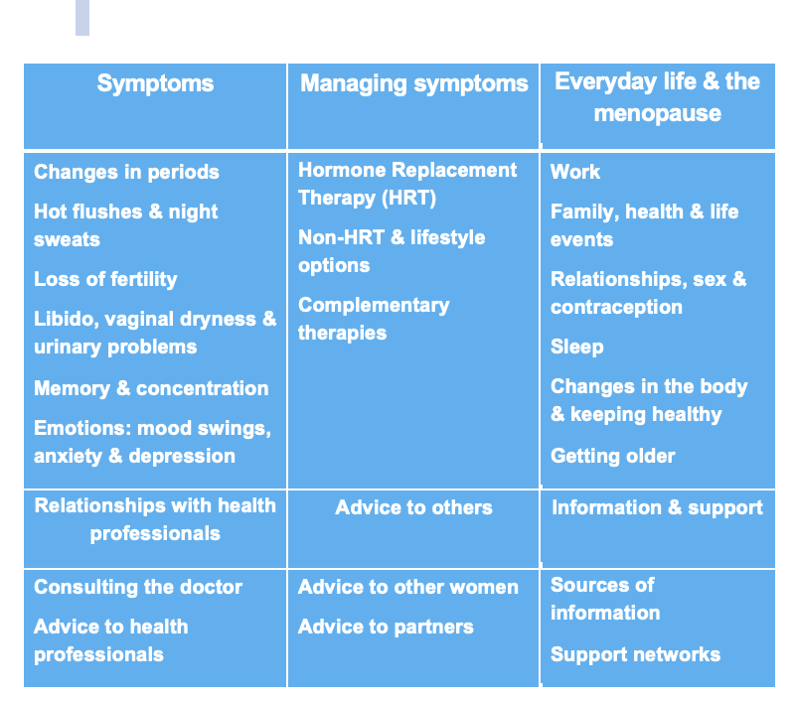

Transcript of interview

MEN10: Maggie; VAW; Peri-menopausal; Age at Int: 49; B’g: Maggie is a psychiatric nurse. She is single with no children. She started the menopause at age 47. Ethnicity: White British.

Outline: For Maggie, increasingly severe premenstrual tension (PMT) led to a missed periods 18 months ago and the onset of hot flushes. Symptoms have now eased but she continues to suffer from insomnia. She feels a sense of loss at not having had children.

Interviewer (I): Could just now tell me a little bit in your own words, about your menopause experience from when you first noticed changes to where you are today?

Respondent (R): [Um] well I’m forty nine now and I, I felt some changes happen a couple of years ago, and before that I hadn’t really given menopause much thought to be honest, [um] but I started to get [um] increased PMT symptoms, so I’d get very sore breasts [um] much more [um] severe symptoms whereas before they’d been quite manageable, and I just I was very moody, and very bloated, and I really noticed my cycles every month and was really keen to get my period and as soon as I did I felt a lot better. [Um] but my periods were fairly regular up till September [um] [um] not last year, the year before, 2007, so [um] at that point [um] I just stopped having periods for about a period of six months, [um] and again I wasn’t too concerned about it, I thought perhaps I, I started to think then, I started to do a bit of reading about the menopause for the, the peri-menopause, as I realised that’s probably what was happening. And [um] sorry I’ve lost the train of thought now.

[Um] so yes so I I had, didn’t have periods for six months, and then I started a relationship and I got [um] one period in the same month that I started the relationship, [um] and then again a gap of about eight months, [um] and again some light bleeding for about two or three days, and that was [um] a couple of months ago. So I think in, in the period of time of about sixteen months I’ve had [um] two lots of quite light bleeding. So [um] according to my Doctor I have to go a whole year before I’m actually officially through the menopause, [um] but I have to say that I’ve felt great, and that I’ve had a few symptoms, classic symptoms like insomnia, which is the most, the thing that bothers me the most I think. And the other thing I get is hot flushes, or flashes, as people call them, [um] so I can feel you know the heat coming up my body from my toes right, and it doesn’t last very long, and to be honest I haven’t found it that uncomfortable, I, it’s I notice it, but [um] it doesn’t bother me very much. [Um] and so the only thing that has bothered me is the insomnia, but it’s more than made up for by the fact that I don’t get PMT anymore, you know, and I feel I actually have a lot more energy than I did when I was experiencing sort of cyclical changes.

I: How many years did you experience the PMT for before your periods started to get erratic?

R: Oh probably about eight years,

I: How did it affect you?

R: [Um] I would have bloating, so feeling sort of, there was fluid retention, [um] I’d feel quite tired and [um] irritable, and more emotional sort of on a bit of a short fuse really, [um] I’d definitely have cravings for sugar. Yeah, and [um] yeah just generally feeling out of sorts really. And not, and funnily enough not really knowing what it was, even though every month I was getting the same thing, but not really taking it in, that [um] in a few days this will be all gone, okay again, and I’ll feel normal again. So [um] and I as I said sore breasts which I, I did do some research about that, and I eventually got some [um] progesterone cream, [um] which I used for I think three or four months, but didn’t seem to help so then I I gave up with it.

I: Was that on prescription or?

R: No that was through the internet, yeah.

I: Did you go to the doctor at all about your PMT?

R: [Er] I didn’t because I didn’t really want to have chemical help for it. And I think I mentioned it to him once or twice perhaps when I’m going for something else, but [um] and he suggested at one point [um] Hormone Replacement Therapy, that was more towards when I was peri-menopausal. But I really didn’t want to to use that so. To be honest I didn’t really think there was much he could do. I could be wrong but,

I: Sure, sure. [Um] and did the PMT have any effect on your relationships?

R: Yeah, [um] I think it had an affect on all my relationships really, [um] just the fact that I wasn’t, [er] at those times of the month I wasn’t really [um] as balanced, as well balanced and didn’t have as much patience, and felt uncomfortable in myself, so I think it would probably [um] also stop me from being as social as I might normally be. Yeah definitely, I think [um] especially in the last, well as I say in the last five to eight years I think.

I: Yeah. So did you feel you got much support?

R: [Um] I think limited support [um] you know. Not, perhaps not as much support as I would have liked, but [um] I think it is, it’s a hard thing to understand if you’re not experiencing it I think. I got a lot of support from my women friends, because they know what it’s like I think. They can relate to it.

I: [Mm] You mentioned also hot flushes, can you tell me a little bit about them?

R: Yeah they’ve been, well they could be any time of day really, and night. I used to get, I think I used to get them a lot at night as well, which I remember just tossing and turning and feeling so hot, like even on a cold night I would be like a furnace, and sweating a lot at night, [um] and then in the day I think at work a lot I remember noticing it, [um] I think perhaps I noticed it more at work because I felt more conscious of it, and I felt that other people perhaps could see me going hot, you know red and hot, but I’m not sure if they could, but [er] I think I was more aware of it when I was at work. [Um] as a sort of embarrassment, but actually [um] it was just like a creeping sensation from my feet up the whole of my body to my head, of heat really, sort of prickly type heat. Yeah.

I: How long did it last for?

R: [Er] really only a few, a couple of minutes. [Um] but it was almost like they’d be like a hot flash, and then there’d be sort of a slow
sort of [um] cooling down period.

I: Yeah. And did you get night sweats as well?

R: [Um] yeah I didn’t ever change the bedding, but I, I’ve, I used to take my nightclothes off whatever and throw all the covers off, and feel very very hot for periods of time, and and that, it’s hard to sleep through that as well.

I: Yeah and did you do anything about it? Did you take anything, or?

R: No, not really. No I just, I think I accepted it as a part of the changes I was going through really.

I: [Mm, mm] So did the hot flushes start about the time missed that first period?

R: Yeah, almost the same time, yeah. And that’s what clued me into the fact that something was happening.

I: [Mm, mm] What about [um] the mood swings, did they continue once you started to miss periods?

R: No they’ve really levelled out a lot. I’ve found that, that’s one of the positive things about not having periods is that actually I don’t feel, I don’t feel those swings that, or the PMT any more at all.

I: How were your periods different?

R: Yeah, just nothing like, I mean I didn’t feel, well I didn’t have the PMT so it was a complete surprise to get any spotting or bleeding and [um] just a very small amount really, [um] didn’t even hardly have to use anything. You know so, very different.

I: You were in a relationship at the time. Did you notice any differences sexually? Some women talk about vaginal dryness, and things like that

R: Yeah, I have noticed that as well, and also I get thrush more easily. I don’t know if that’s linked to the menopause, or not, but I’ve noticed I’m definitely dryer and have more of a tendency towards thrush.

I: And do you do anything about that?
R: [Er] just use a lubricant, and [um] and obviously if I get thrush badly enough I’ll use the treatment. So, either the pessaries, cream or the oral capsule.

I: You mentioned the insomnia as being a bit of a problem for you. How often did that happen?

R: It’s still happening now, and it’s, it’s only got a pattern in the sense that I very rarely get a good night, a whole night’s sleep. So sometimes I’ll drop off [um] no trouble at all and I’ll wake up at one or four, or five, just a bit too early you know, and other times I just can’t drop off and I [um] I finally will drop off and then I’ll sleep very heavily until morning. Yeah. I mean I have tried various things for that, some of which worked, but not consistently all the time.

I: What sort of things did you try?

R: Yeah. I, I’ve used lots of different things, I’ve used [um] Valerian, in tincture and capsules. And they worked really well for a short time, then they seemed to not work. And they also worked really well for getting off to sleep, but not so good for when I wake up in the middle of the night and can’t get back to sleep. [Um] and I tried melatonin which again seemed to work fairly well for a while, [um] and I, in amongst that period I was doing some night shifts and I was just not sleeping in the day, and I got a bit desperate so I went to the GP and the GP gave me Temazepam so I’ve got [um] I get thirty from him about every five months, and I use them sort of very sparingly really, I take a half when I really need to, if I feel like I have to sleep otherwise I won’t be able to work the next day.

I: And does it have an effect on your day to day work?

R: Yeah. Oh definitely. Definitely. I just feel tired, you know, more tired, I don’t feel I can concentrate as well, I don’t have as much energy to bring to work, [um] I feel less sort of inclined to go out socially [um] I mean I still do but I have less energy to do that. [Um] yeah, being tired is yeah, it’s hard, it affects everything actually.

I: Was there any link between [um] waking up and the hot flushes?

R: [Er] yeah, at first, I mean I don’t really have any hot flushes now. But [um] definitely at first, I think that’s what got me into a pattern of waking up. Yeah. Because I used to sleep really well.

I: [Mm, mm] Have you tried anything to relieve the hot flushes?

R: No, not really, no. I mean if, what I have done is talked to friends and talked to people I know who have been through it, or are going through it, and [um] you know they’ve suggested various things, but I really didn’t, it didn’t warrant it, I mean it didn’t bother me enough really.

I: [Mm] so do you and your friends talk fairly openly about the menopause?
R: I think they will if you ask. People don’t generally talk, it’s its like sex as well, people don’t generally talk about it sort of spontaneously unless you’re very close or, [um] quite you know outspoken that way, but [um] yeah I think people are keen to talk about it if you ask them, yeah.

I: [Mm, mm mm] What about consulting your GP about any menopausal symptoms?

R: [Um] I’ve been for the thrush, [um] oh but that’s not specially, specifically linked to the menopause, but I [um] not really I don’t, I don’t really think he would be very helpful.

I: Why is that?

R: I don’t, well when I, I have spoken about it once or twice, and he’s said, [um] “Have you considered [um] hormone, hormone replacement therapy?” And I haven’t really, and I don’t really, I think that’s, that’s what he would suggest really for me, [um] I get, I get the impression that he doesn’t really have much time, he’s you know, perhaps I don’t really feel that I need to go to him for, I can get the information I need from the internet or from friends, or from reading books, you know, and then perhaps if I went with a suggestion I would go. If there was something he could give me, then I would go and discuss it with him. But I wouldn’t go to him just for general advice because I think he’s not specialised enough to be able to give it to me

I: Tell me about your decision not to take HRT.
R: [Um] well [um] I think if my symptoms had been worse or if I felt somehow debilitated by them in a way that I couldn’t cope with, I certainly would’ve considered it, but [um] I feel actually quite positive about the menopause so far [laughs], I don’t feel I need a, you know, to take any, I mean as I say the one thing that bothers me is not sleeping well, but I don’t know if hormone replacement would even help with that, so, and I’d rather not, I’d rather get through it in a more natural way if I can.

